What are the different types of frameworks?

Below are the different types of frameworks:

Module Based Testing Framework: The framework divides the entire “Application Under Test” into the number of logical and isolated modules. For each module, we create a separate and independent test script. Thus, when these test scripts have taken together builds a larger test script representing more than one module.

Library Architecture Testing Framework: The basic fundamental behind the framework is to determine the common steps and group them into functions under a library and call those functions in the test scripts whenever required.

Data Driven Testing Framework: Data Driven Testing Framework helps the user segregate the test script logic and the test data from each other. It lets the user store the test data into an external database. The data is conventionally stored in “Key-Value” pairs. Thus, the key can be used to access and populate the data within the test scripts.

Keyword Driven Testing Framework: The Keyword Driven testing framework is an extension to Data-driven Testing Framework in a sense that it not only segregates the test data from the scripts, it also keeps the certain set of code belonging to the test script into an external data file.

Keyword driven framework

For each test case step if you are calling a keyword or function, then it is called keyword driven framework

Example

Hybrid Testing Framework: Hybrid Testing Framework is a combination of more than one above mentioned frameworks. The best thing about such a setup is that it leverages the benefits of all kinds of associated frameworks.

Behavior Driven Development Framework: Behavior Driven Development framework allows automation of functional validations in an easily readable and understandable format to Business Analysts, Developers, Testers, etc.

In End to End Testing framework – Need to initialize driver and close driver for every test. So setup and tear methods are written under @BeforeMethod and @AfterMethod.

In Sequential Testing- setup and teardown methods are written under @BeforeSuite and @AfterSuite

Sending email

Java mail api depenedency to be added

Javax.mail – 1.6.3

Inside it there are many classes

Geeksforgeeks.org is having code to send simple email.

Need to do settings in gmail also.

Security- less secure app access to be turned on. And then run the send email code

Add Test summary in body through testing and use send email method.

Try doing that as home work.

Data driven testing

Table has primary key etc cannot be verified. We can only validate record created or not etc.

First we need connection details and user in database. In general we do read only operations

Username root

Password Selenium

Then give database name

After installation it is available in programs

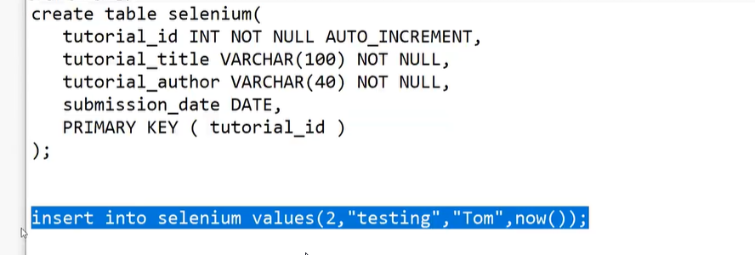

To fetch data , you can use

Select \* from selenium

JDBC to be used to do it in automation

Database dependency to be added in pom.xml – eg: mysql

Register the driver

Créate connection

Créate statement

Use Assertion

Close connection

TestNG is framework that we are using.

Keyword , datadriven, hybrid etc are approaches.

Data driven framework is basic framework.

90% of companies use Page Object Model.

Below is the Folder stucture of data driven

Writing Base class

Two properties files are required- one for OR(Object repository) and other for config.properties)

What is PropertyConfigurator? Log4j class to be imported

Integer.ParseInt() to convert into integer

Paste the keywords present in properties class in your base class(example click, type etc)

Need to add listeners to TestNG.XML

What is scenario context in specflow?

Can we do complete GUI Testing using selenium?

Ensure “browser= chrome”used in test is matching with config.properties variables

Log4j results gets stored in applog.txt.

Multiple dataprovider can be written in DataUtil class for multiple Excel workbooks.

Java reflection api class- add it in Getdata. Syntax: getData(Method m)

This is to get the name of method where the corresponding data provider is called.

This name is given to sheet name . Now the test will pick the respective data sheet.

Now capture screenshot to be called in listenerclass -OnTestFailure method

Screenshot name generated automatically with testcase and current date.

Maven is not just dependency management tool. We can use it to build tool.

Go to cmd Maven folder

Mvn clean - to delete data in target folder

Mvn test – to run tests

getOptions is used to get count of options in list box

webdriver does not have array. It is having collections

List<WebElement> values = findelements(By.tagname) method is used to find all elements with option tag

Values.size();

Values.get(0).getattribute(“value”);

How to capture number of links on web page.

Using anchor tag.

Selenium july 1st 2023

Browser options can be used for cookie settings. For example for Chrome. Check right option for it. Below is the code for turning off notifications in Chrome.

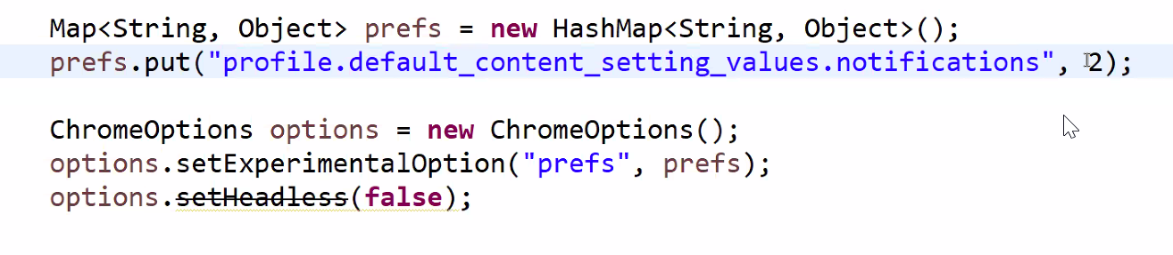

Method chain concept

Now Let us créate new base class and change our framework to end to end

Remove static keywords

Many companies use only page object model without page factory

Need to initialize driver (setup method) before every test case for end to end testing.

Fis code can be seperated and kept under beforesuite

Remove browser from config and Pass browser as parameter to setup method. This is to run same test in multiple browsers during the run time.

Remove or.properties code from base class

Now créate new test case

Run it using testNG

Verify page title of Brand page is a common action required for cars page. So better we créate a seperate base class “CarBase” for this and call the method to your test.

Docker in local machine

AWS

Créate instance

Stop instance

Terminate instance

Install java

Below course is suggested to Master frameworks.

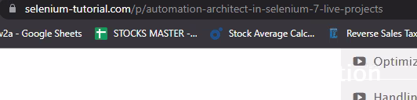

Page object model

Creating common classes for pagenavigation , for header, for footer, or for any common actions to be performed

Setup(driver) called directly in test class as

In Data driven Test cases and business logic is combined.

In Page object model, Test case is seperated from business logic.